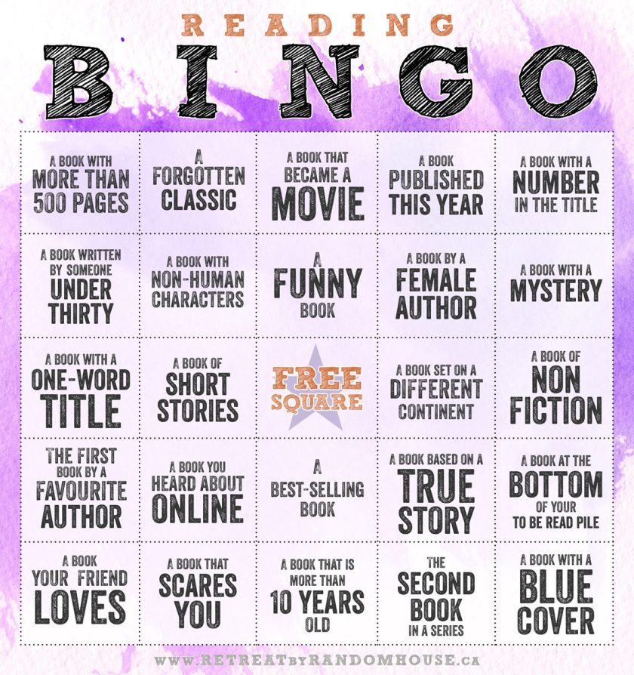

Bingo: _________________ Blackout: ____________________

