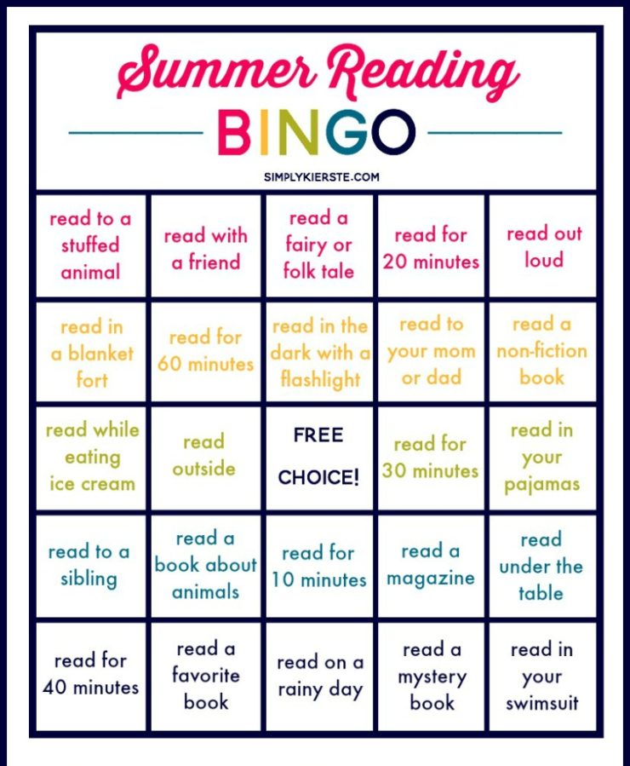
Bingo: __________________ Blackout: __________________

